you have to a take a txt file and if it find any word starting with with vowels it will give you the count of vowels in the file and it should return a txt file as count of the vowel  
  
  
  
import java.io.*;  
import java.util.*;  
  
 public class main {  
  
 public static void main(String[] args) {  
 String inputFilename = "input.txt"; // Path to your input text file  
 String outputFilename = "vowel_count_output.txt"; // Path for the output file  
  
 try {  
 *countVowelsInFile*(inputFilename, outputFilename);  
 } catch (IOException e) {  
 e.printStackTrace();  
 }  
 }  
  
 public static void countVowelsInFile(String inputFilename, String outputFilename) throws IOException {  
 // Define the vowels  
 String vowels = "aeiouAEIOU";  
 int vowelCount = 0;  
 int wordsStartingWithVowel = 0;  
  
 // Read the input file  
 BufferedReader reader = new BufferedReader(new FileReader(inputFilename));  
 StringBuilder text = new StringBuilder();  
 String line;  
  
 // Reading the file content line by line  
 while ((line = reader.readLine()) != null) {  
 text.append(line).append(" ");  
 }  
 reader.close();  
  
 // Split the text into words, remove punctuation  
 String[] words = text.toString().replaceAll("[^a-zA-Z ]", "").split("\\s+");  
  
 // Loop through each word  
 for (String word : words) {  
 // Check if the word starts with a vowel  
 if (word.length() > 0 && vowels.indexOf(word.charAt(0)) != -1) {  
 wordsStartingWithVowel++;  
 }  
  
 // Count vowels in the word  
 for (char c : word.toCharArray()) {  
 if (vowels.indexOf(c) != -1) {  
 vowelCount++;  
 }  
 }  
 }  
  
 // Write the results to the output file  
 BufferedWriter writer = new BufferedWriter(new FileWriter(outputFilename));  
 writer.write("Vowel count: " + vowelCount + "\n");  
 writer.write("Words starting with a vowel: " + wordsStartingWithVowel + "\n");  
 writer.close();  
  
 // Print the result on the console as well  
 System.*out*.println("Vowel count: " + vowelCount);  
 System.*out*.println("Words starting with a vowel: " + wordsStartingWithVowel);  
 System.*out*.println("just for change");  
 System.*out*.println("just f change");  
 System.*out*.println("just fr change");  
 }  
 }

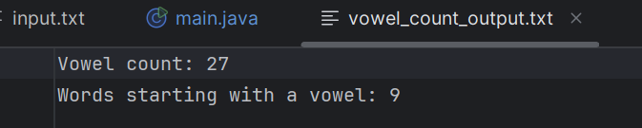  
  
  
Git commands screenshots  
  
